**Patching a Tamagotchi Smart to English without a custom SmaCard**

Most commonly, the English patch is applied via a custom SmaCard, which you can either make yourself, or buy from someone who's selling it. However if, for some reason, you are not able to patch this way, it is also possible to apply the English patch by flashing the English firmware onto the chip. That’s what this guide is for! This guide is intended to be helpful even if you have no firmware experience, the process is actually very simple.

You will need:

* A Tamagotchi Smart
* A CH341A programmer with a clip
* A windows machine with AsProgrammer (Or a mac with mac equivalent programming software)
* A copy of the English patch (Note - the patch made for the custom SmaCard method has an update header. Ensure the English patch file you have does NOT have this)

Guide written by #teallen, English patch created by #studded.net  
You apply this patch at your own risk, neither me nor anyone else involved is responsible for any damage to your device. It’s important to follow the steps carefully, and make a backup of your firmware just in case anything goes wrong (Step 4)

Sharing firmware is prohibited in the Tamagotchi Collectors Discord Server, and this includes the English Patch. It is also prohibited to ask for someone to share firmware.

**Step by Step**

1 - **Get a copy of the English patch SPECIFICALLY for patching this way.**

The version of the patch that’s created for patching with a card has an update header that needs removing, so don’t use that one.

It's forbidden to share/ask for firmware in the Tamagotchi Collectors discord server, but hopefully whoever sent you this guide has also sent you the file you need!

2 - **Open up your tamagotchi smart.**   
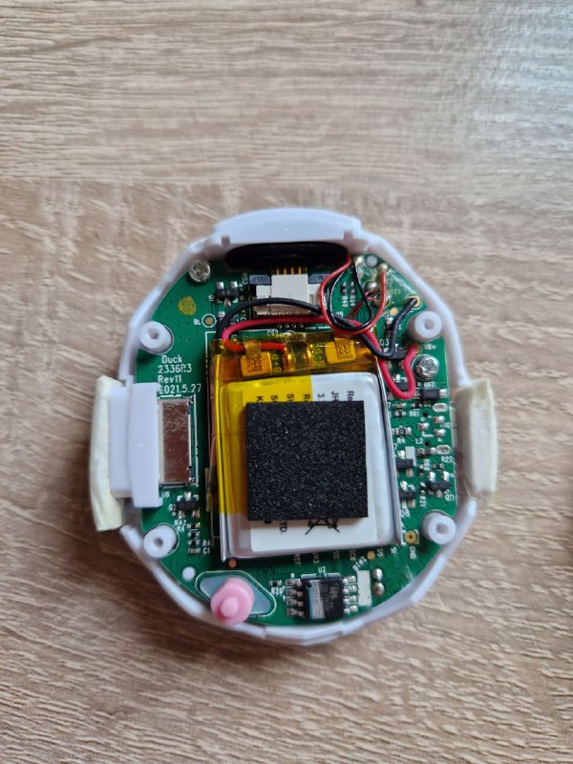  
There are 4 screw caps that need to be removed, and 4 screws underneath them. I also remove the reset button, as it could easily get lost.

The chip you need to clip on to is at the bottom of the board, next to the reset button.

3 - **Connect the smart to the CH341A programmer** (see pics)

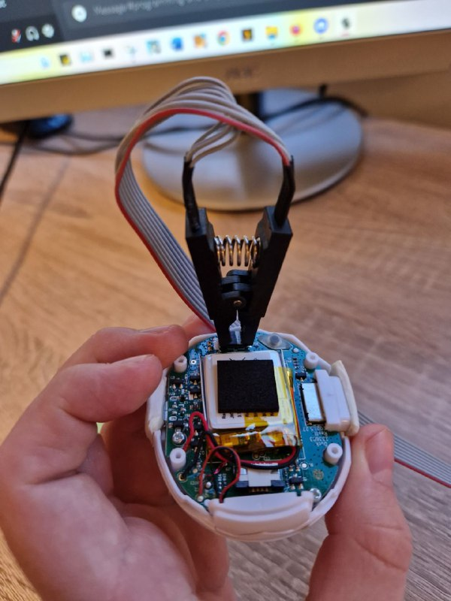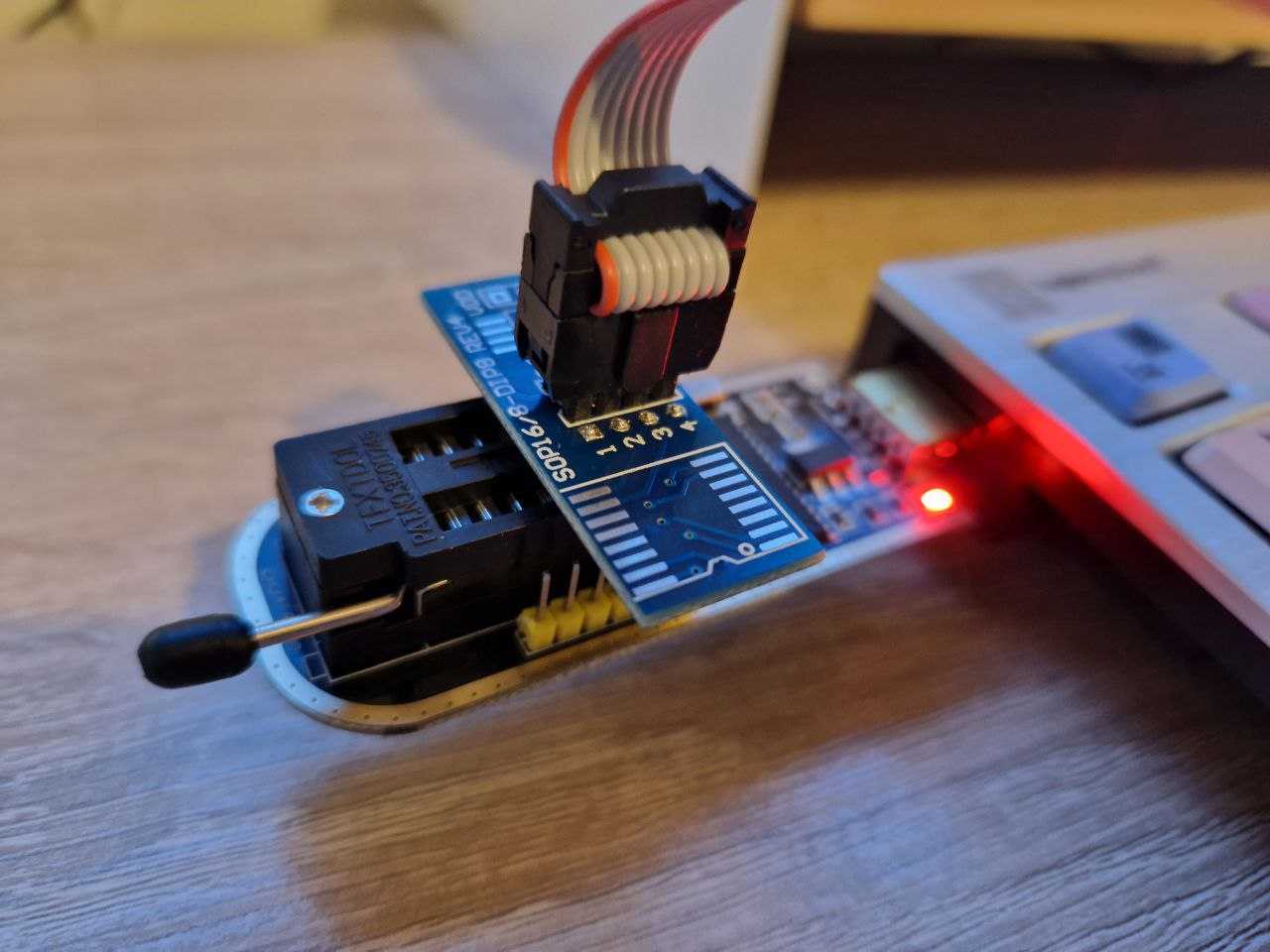

There’s a faint dot on one of the corners of the chip. Make sure the red wire on your clip is aligned with that dot.

When connecting the other end of the clip to your CH341A programmer, ensure you’ve connected it the way I have in the pictures.

For both ends, make sure everything is connected solidly, or else it won’t work.

3 - **Open AsProgrammer and under IC, select MX25L12805D**

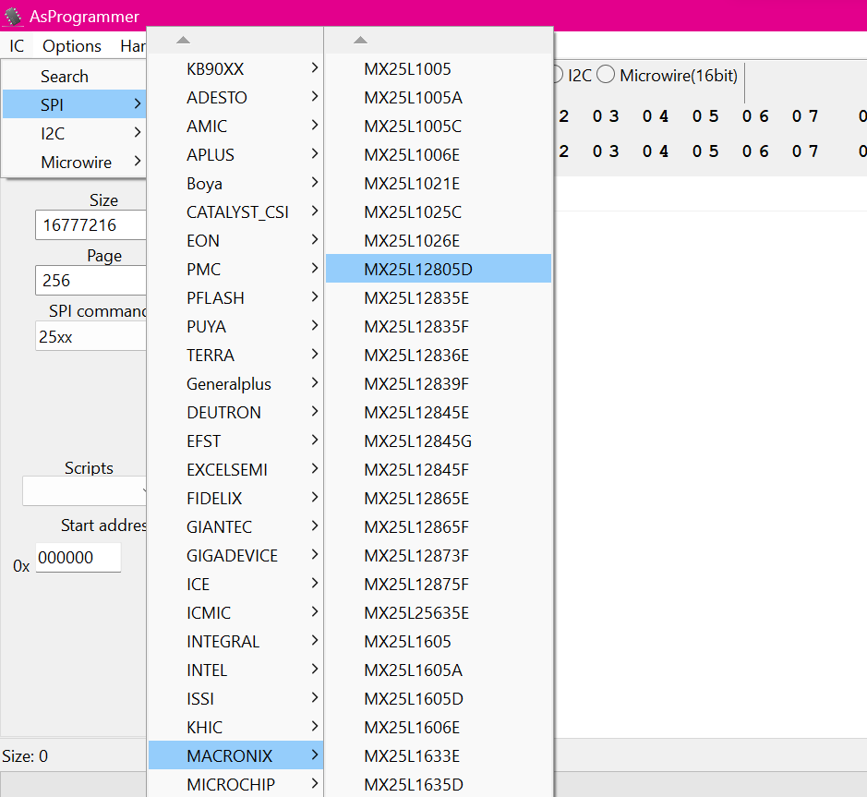  
The chip is a KH25L12833FM21-10G. You don’t need to know what that means, you just need to know to go   
**IC > SPI > MACRONIX > MX25L12805D**

4 - **Create a backup of your firmware**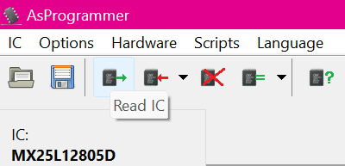

In AsProgrammer, Select the “Read IC” tool.

We’ll be erasing this firmware in the next step, and you really don’t want to do that without backing it up first. It’s also a good way to test that everything is working properly.

It will take a couple of minutes, and afterwards you should be able to see the firmware. When it’s done, select “Save File” and save it wherever you want. If the firmware comes back with “F” or “0” at every point, see the “Troubleshooting” section at the end of the guide.

**DO NOT go to the next step before completing this step.**

5 - **Erase the firmware currently on the device**

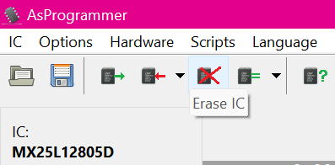

Select “Erase IC” and don’t touch it until it says it’s complete. The original firmware has to be erased so the new firmware can be programmed in its place.

6 - **Open the patch file**

You should notice that the numbers and letters in the middle of the screen have slightly changed. If you look at the file path above the progress bar, it will say which file you have currently open.

7 - **Select “Program IC”**

This will program the firmware you just opened onto the device. Do Not interrupt the device while it's doing it, or you could brick it. Just leave it and wait until it's done. It should take a few minutes.

9 - **Unplug the smart and test it**

You can hold the back in place, no need to put the screws back in until you've confirmed it's working. Power the device up, and it should be in English! Congratulations!

**An Overview of AsProgrammer**

AsProgrammer is actually very intuitive once you know what you need to do. I’ve labelled the most important stuff below:

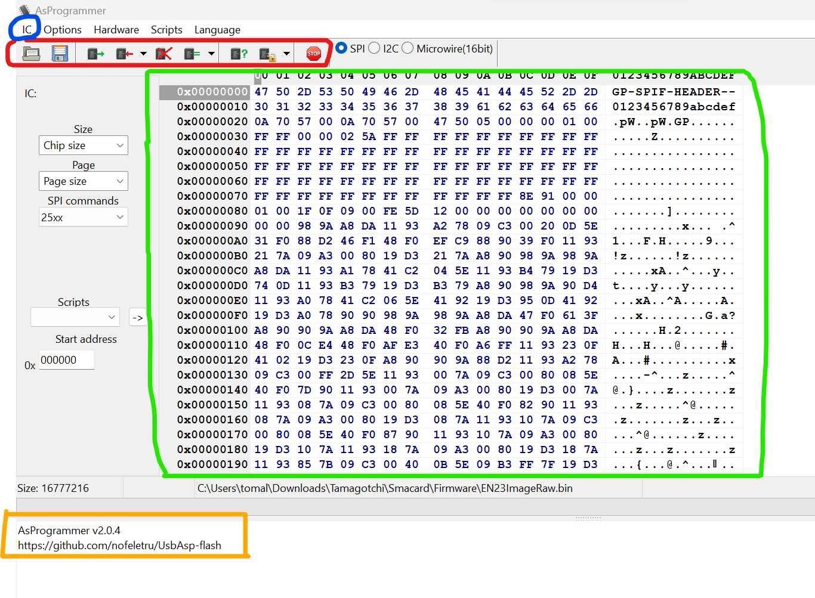

**Blue** - This is where you select the IC (In this case, MX25L12805D)

**Red** - From left to right:  
[Open] [Save] [Read] [Program] [Erase IC] [Not needed for this x3] [Stop Button]

These are the tools you’ll need to use during this process

**Green** - This is where you’ll see any firmware you open/read. It’ll be a jumble of numbers and letters

**Orange** - This is where you can see the progress of what you’re doing. It’ll tell you when each step is complete, as well as any errors

**Troubleshooting**

AsProgrammer can’t connect to the CH341A programmer

* Make sure you have the correct drivers installed. After installing drivers, try again. It should work
* If installing drivers doesn’t fix it, your programmer may be busted. Buy a new one

After reading the firmware, the results are just coming back as “F” or “0” for every point

The programmer isn’t getting a proper reading of the firmware

* Ensure all cables are connected in the correct place/the right way round
* Ensure you’ve selected the correct IC
* Make sure the clip is very securely attached to the chip

After patching, the device is still in Japanese

You either didn’t wipe the original firmware, or didn’t open the new firmware before programming

* Select “Erase IC” before programming
* Ensure you’ve opened up the English patch and try programming again (You can see which file you have open by looking at the file path above the progress bar)